
NAME: VICTOR MWANGI
ADM NO: BSCCS/2024/53087
COURSE: BACHELOR OF SCIENCE IN COMPUTER SCIENCE
UNIT CODE: BIT4139
UNIT NAME: ETHICAL HACKING AND COUNTER MEASURES

LECTURER: NYORO MICHAEL

Table of Contents
WEEK 1 3
Verifying the install 3
Basic Scan 3
Week 2 4
Port Scanning 4
Footprint Scan 5
Week 3 6
Information Gthering 6
IP Address & Technologies 6
Domain Registrar 6
Email Patterns 8
Week 4 9
SCANNING AND ENUMERATION 9
Port and Service Scan 9
OS Identification & Shared Folders 10
Sub-Domain 11
Week 5 13
Gaining access 13
SQL injection Test 13

WEEK 1

Verifying the install
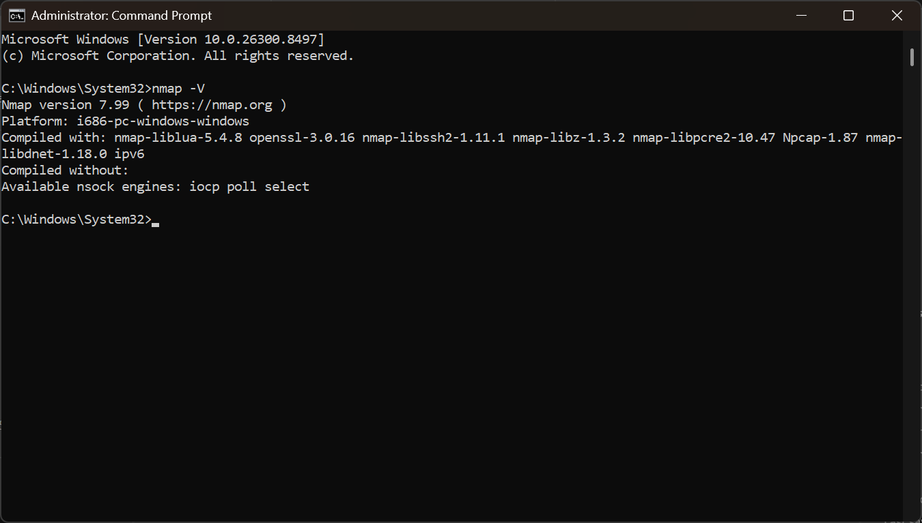
Fig 1: The verification process of nmap

Basic Scan
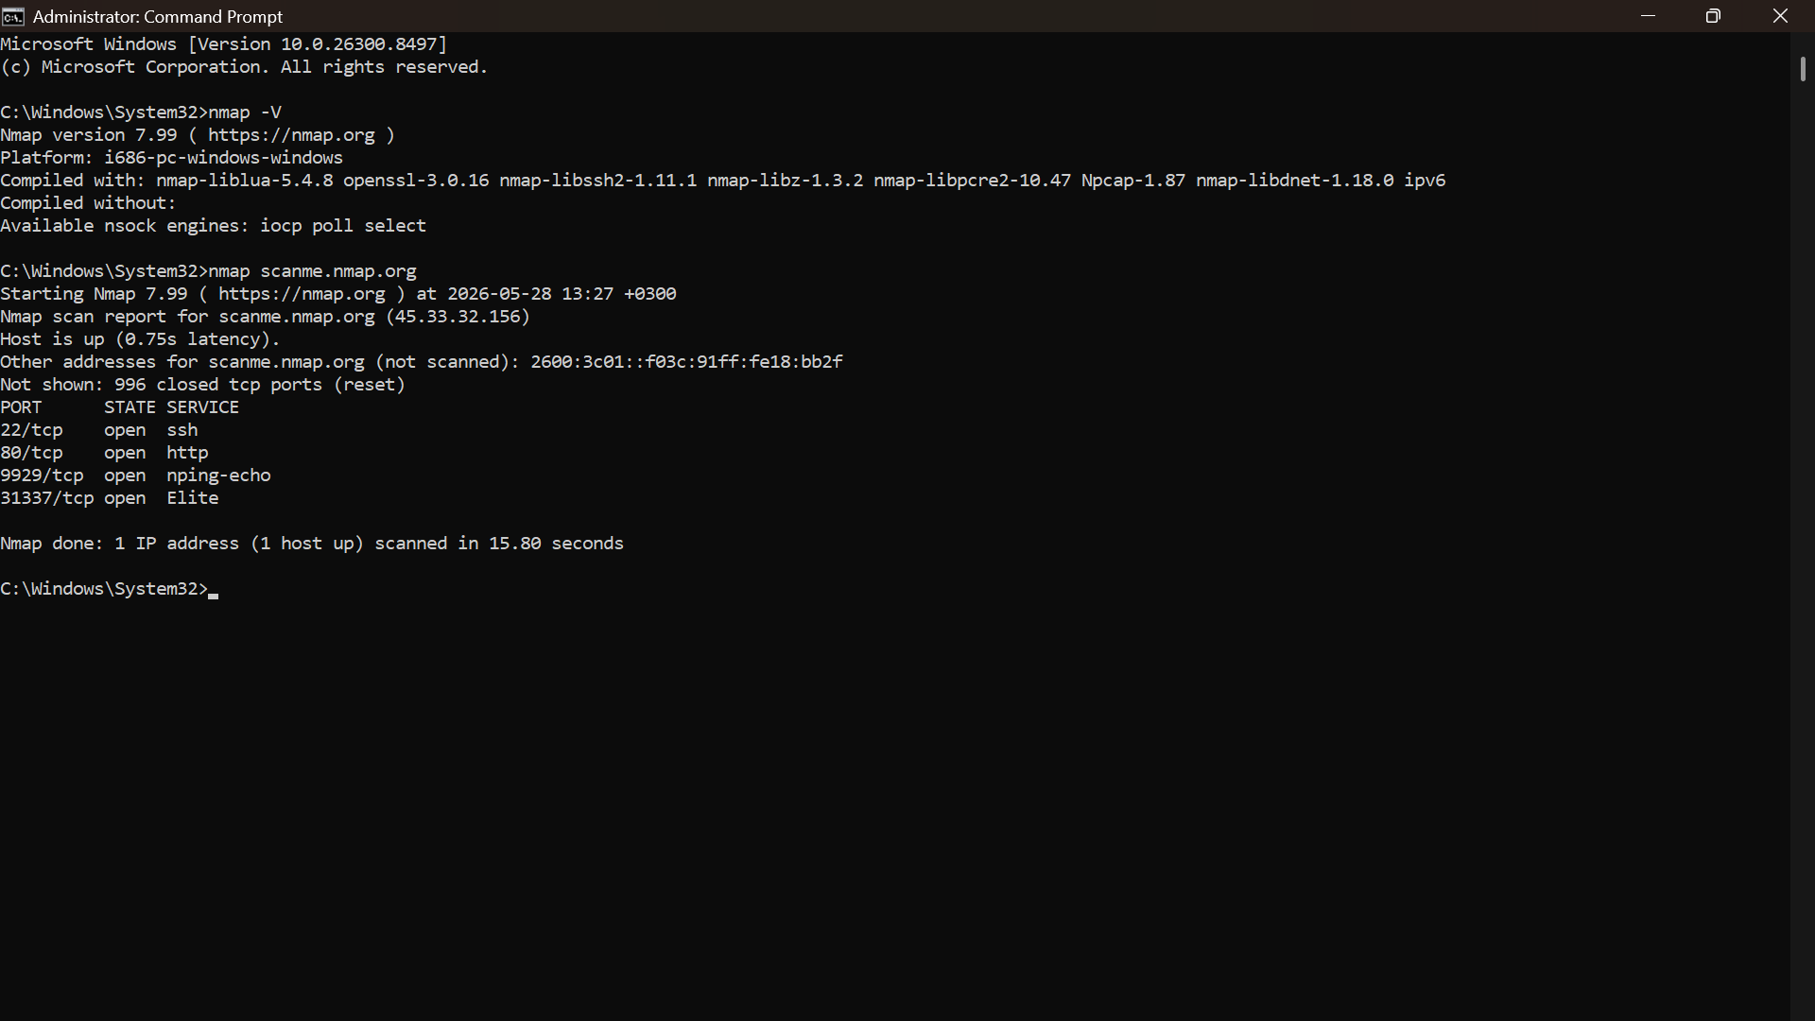
Fig 2: The basic scan

Week 2
Port Scanning
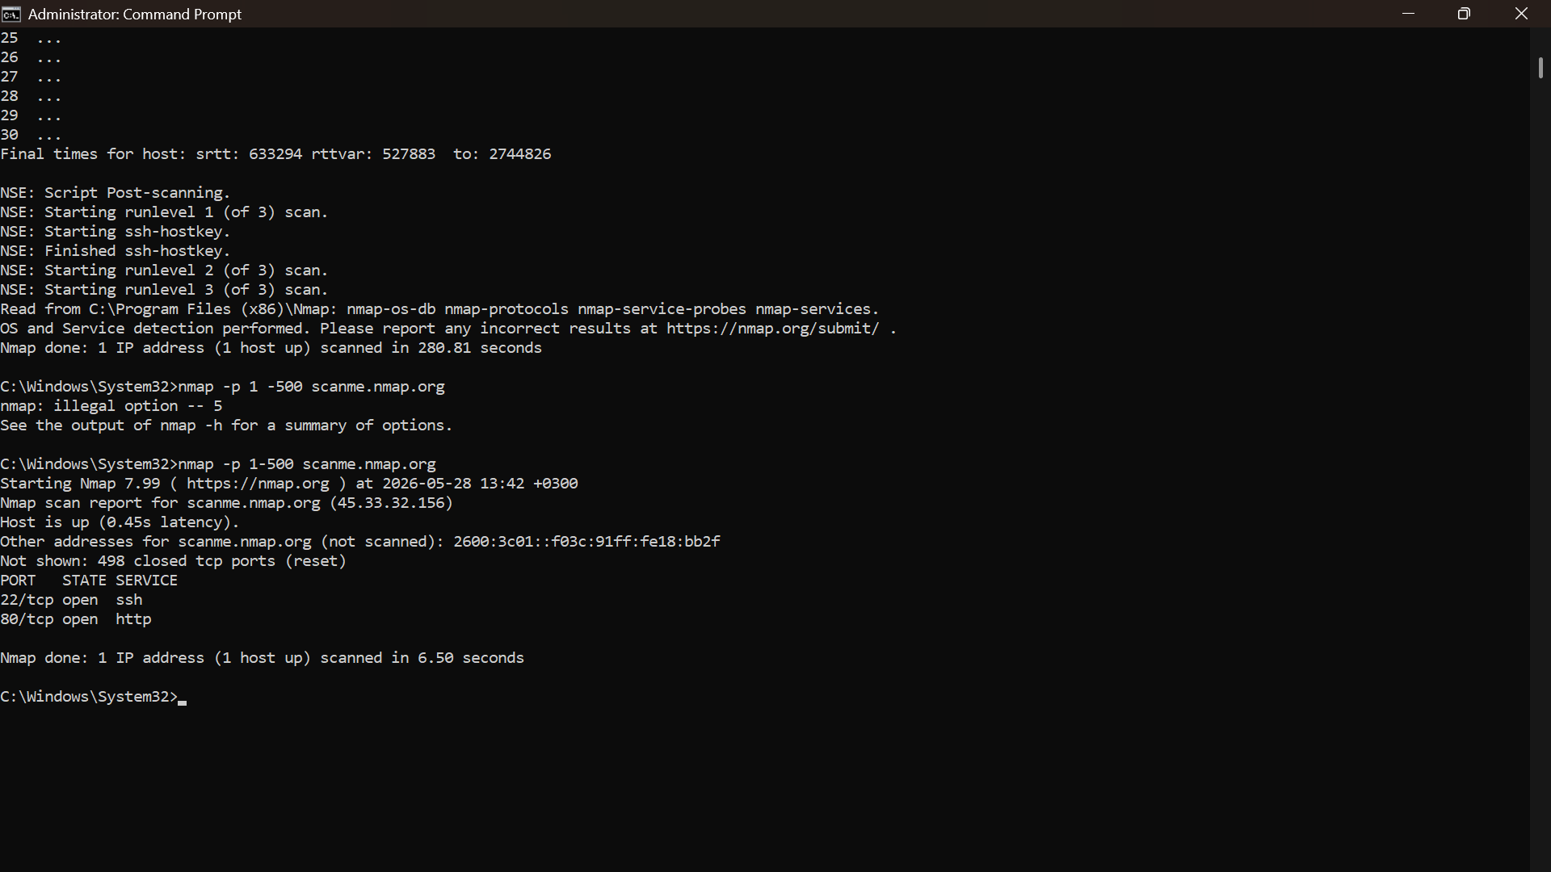
Fig 3: The scanning of ports

Footprint Scan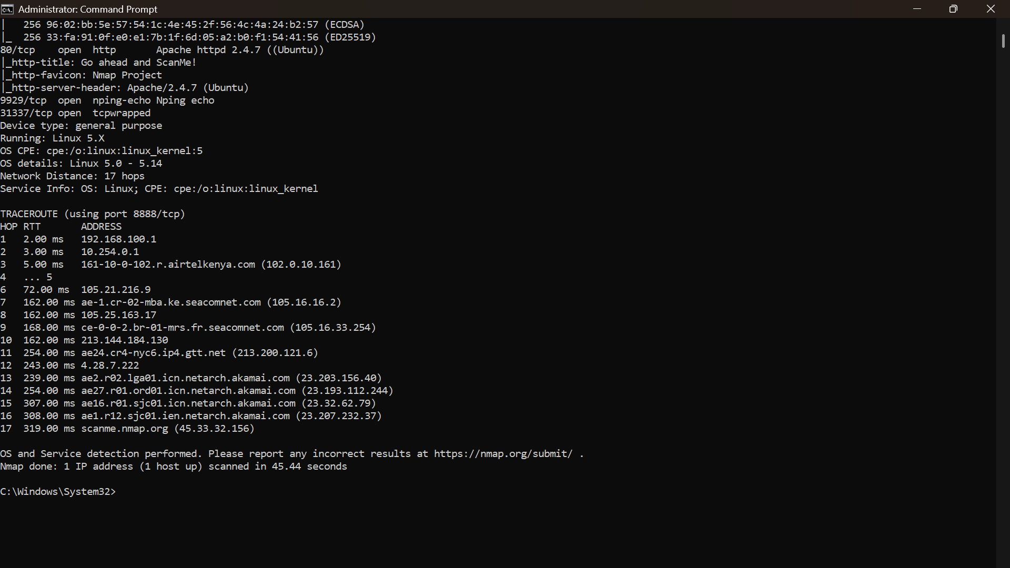
Fig 4: The footprint scan

Week 3

Information Gthering

IP Address & Technologies
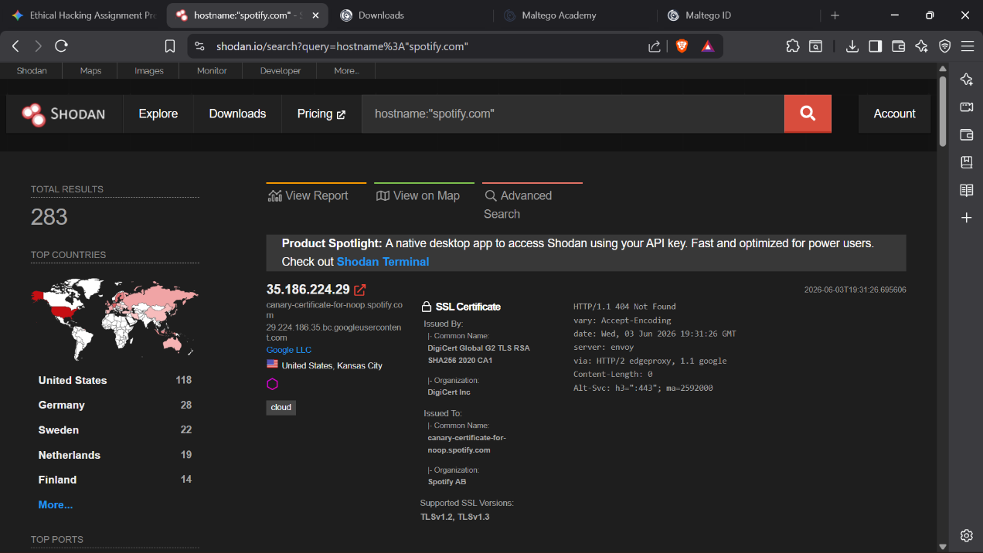
Fig 5: The Shodan website screenshot showing 35.186.224.29, Envoy, and the SSL cert

Domain Registrar
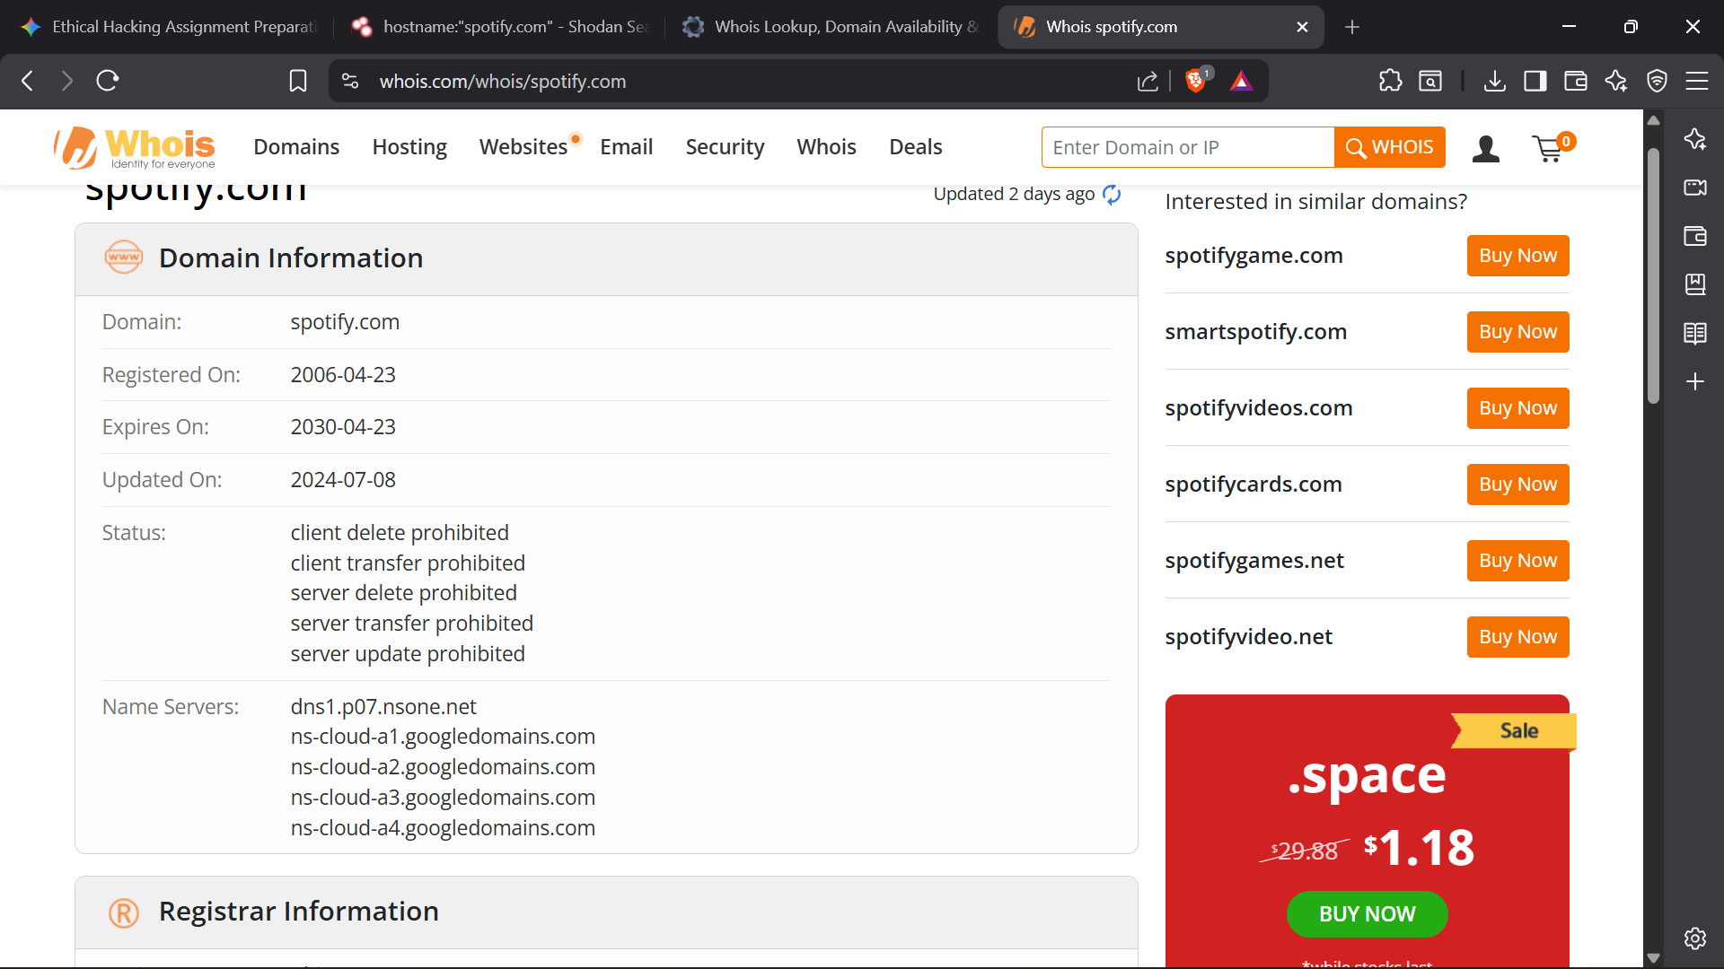
Fig 6: the registrar for the target domain.


Fig 7: the registrar for the target domain.

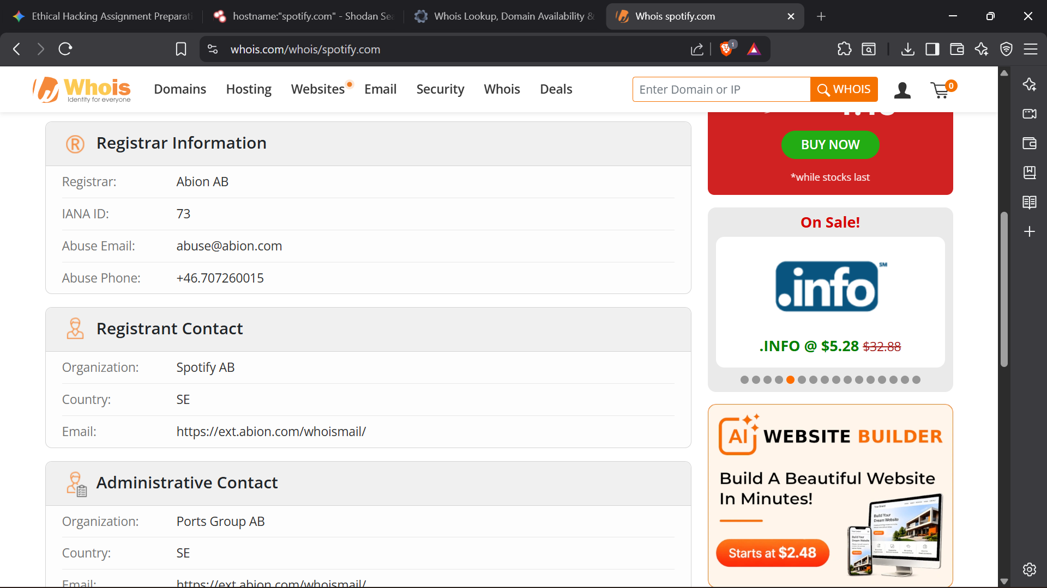
Fig 8: the registrar for the target domain.

Email Patterns
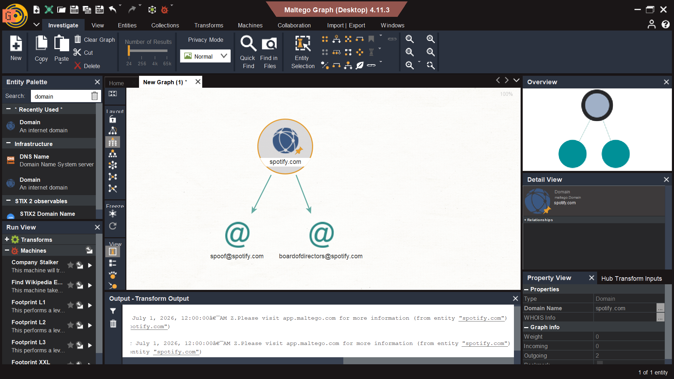Fig 9: Email patterns discovery via maltego

Week 4

SCANNING AND ENUMERATION

Port and Service Scan
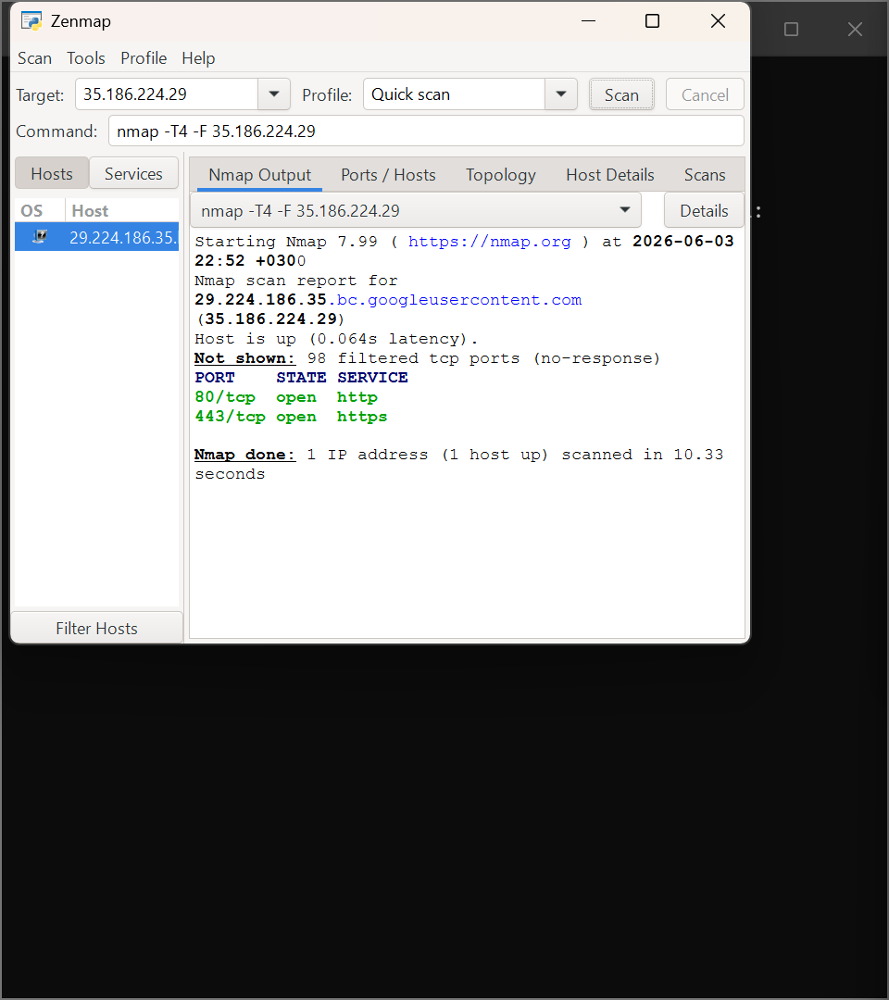
Fig 10: The Zenmap intense scan of 35.186.224.29 showing ports 80 and 443

OS Identification & Shared Folders
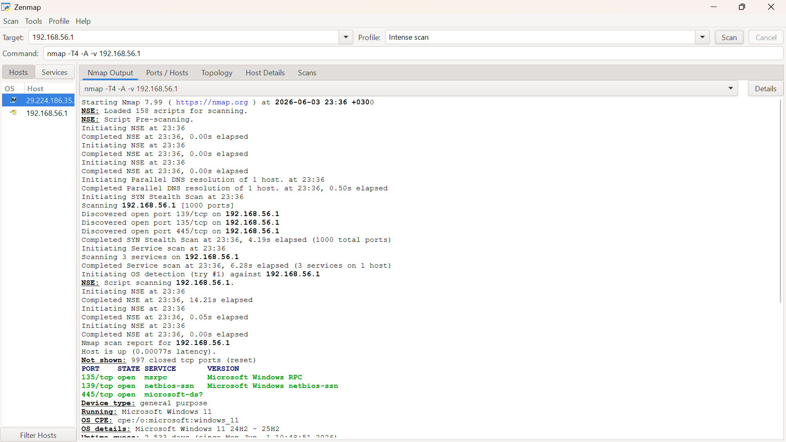
Fig 11: The Zenmap intense scan of your local 192.168.56.1 machine showing Windows 11 and ports 139/445
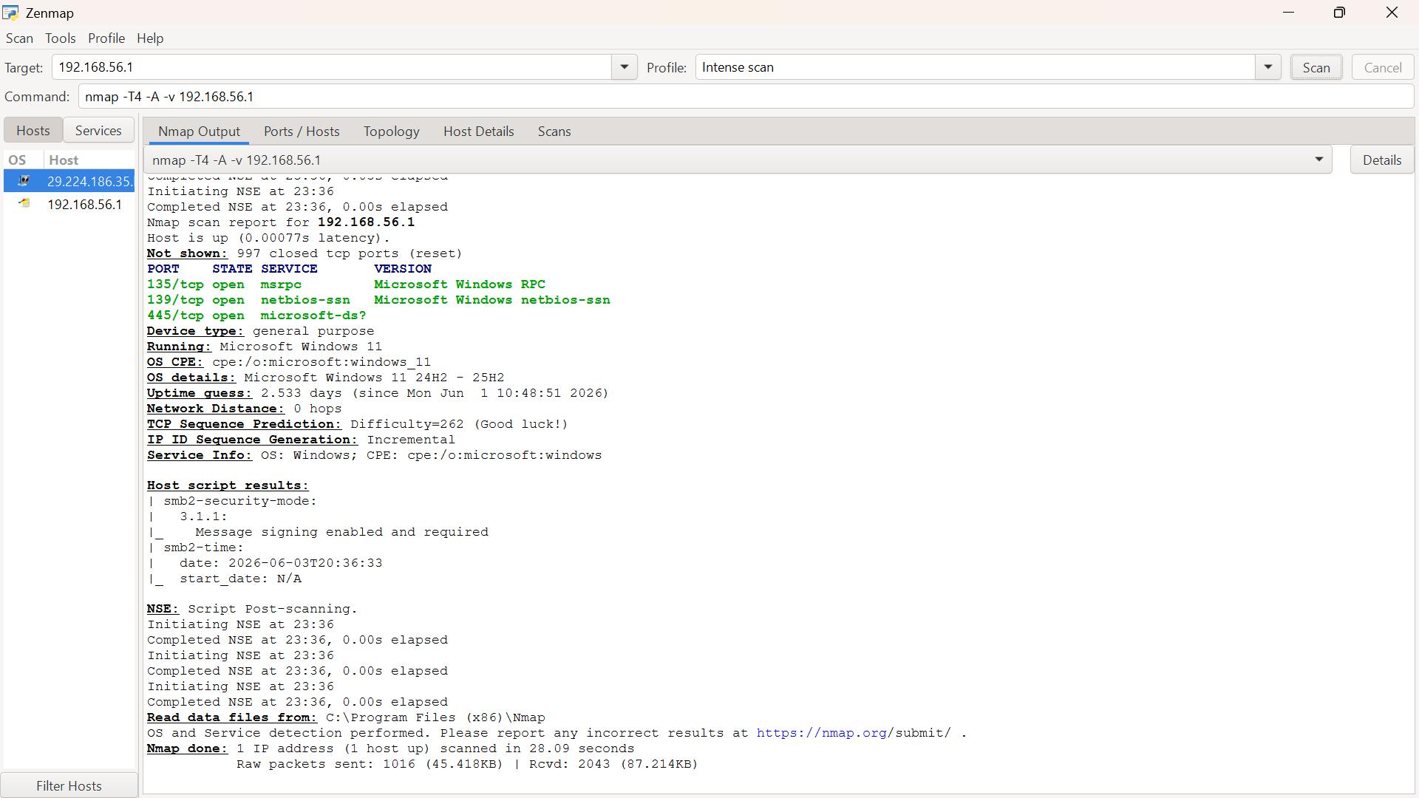
Fig 12: The Zenmap intense scan of your local 192.168.56.1 machine showing Windows 11 and ports 139/445

Sub-Domain
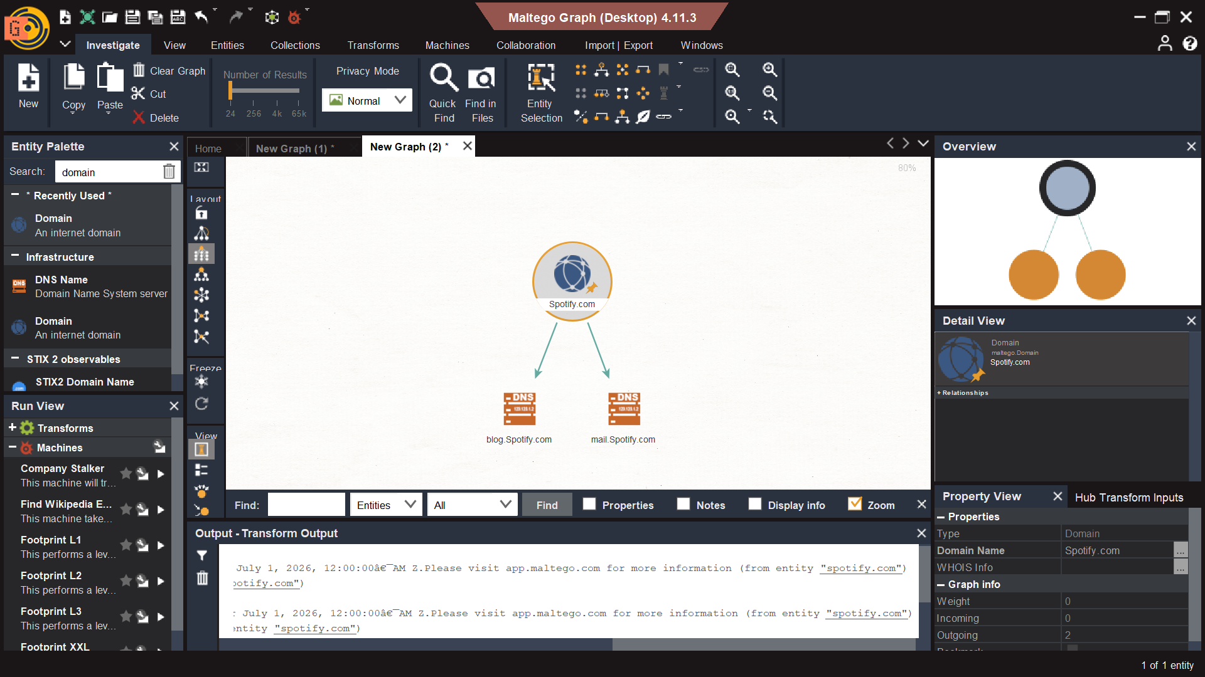
Fig 13: Maltego infrastructure and subdomain mapping

Week 5

Gaining access

SQL injection Test
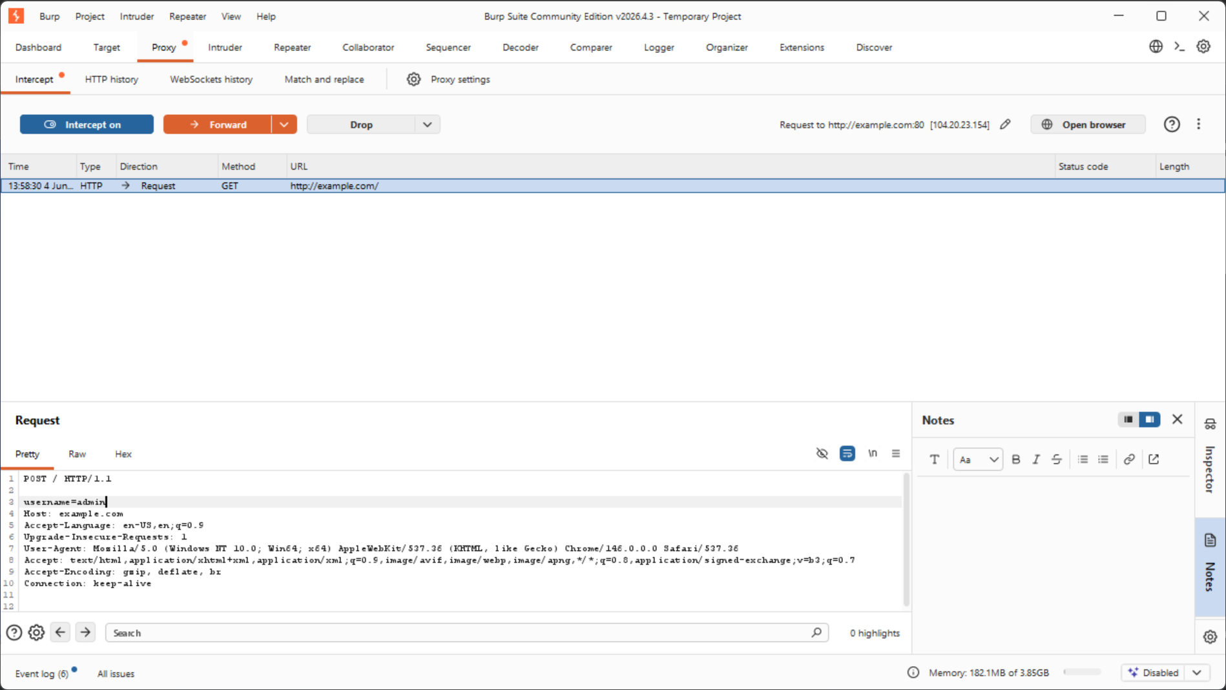
Fig 14: Sql injection using burp suite

